

**NUST COLLEGE OF**

**ELECTRICAL AND MECHANICAL ENGINEERING**



**Rehabilitation of Stroke Patients using Motor Imagery**

**and Off-the-shelf Equipment (OpenBCI)**

DE-35 (DCE)

***Submitted by***

PC Osama Afnan Khan

NS Wajdan Ali

NS Umer Saleem

PC Sadar Muneer

**BACHELORS**

**IN**

**COMPUTER ENGINEERING**

**YEAR**

**2017**

**PROJECT SUPERVISOR**

ASST. PROF. ALI HASSAN

DR. SHOAB AHMED KHAN



**NUST COLLEGE OF**

**ELECTRICAL AND MECHANICAL ENGINEERING**



**Rehabilitation of Stroke Patients using Motor Imagery**

**and Off-the-shelf Equipment (OpenBCI)**

DE-35 (DCE)

***Submitted by***

PC Osama Afnan Khan

NS Wajdan Ali

NS Umer Saleem

PC Sadar Muneer

**BACHELORS**

**IN**

**COMPUTER ENGINEERING**

**YEAR**

**2017**

**PROJECT SUPERVISOR**

ASST. PROF. ALI HASSAN

DR. SHOAB AHMED KHAN

# DECLARATION

We declare that in this report no part of the work done has been submitted in favor or support of an application for another qualification or degree of this or any other institute or university of learning. If any plagiarism found, we will be fully responsible for every action taken against us; depending upon the seriousness of the proven offence, even leading to the cancellation of our degree.

# COPYRIGHT STATEMENT

* Copyright in text of this thesis rests with the student author. Copies (by any process) either in full, or of extracts, may be made onlyin accordance with instructions given by the author and lodged in the Library of NUST College of E&ME. Details may be obtained by the Librarian.
* This page must form part of any such copies made. Further copies (by any process) of copies made in accordance with such instructions may not be made without the permission (in writing) of the author.
* The ownership of any intellectual property rights which may be described in this thesis is vested in NUST College of E&ME, subject to any prior agreement to the contrary, and may not be made available for use by third parties without the written permission of the College of E&ME, which will prescribe the terms and conditions of any such agreement.
* Further information on the conditions under which disclosures and exploitation may take place is available from the Library of NUST College of E&ME, Rawalpindi.

# TABLE OF CONTENTS

Contents

DECLARATION 3

COPYRIGHT STATEMENT 4

TABLE OF CONTENTS 5

TABLE OF FIGURES 7

ACRONYMS 9

ACKNOWLEDGEMENTS 10

Abstract 11

1 Chapter 1: Introduction 12

1.1 Introduction 13

1.2 History 14

1.3 EEG Signals 15

1.4 Motivation 17

1.5 Objectives 18

2 Chapter 2: System Overview 19

2.1 System Overview 20

2.2 Tools: 20

2.2.1 Hardware Tools 20

2.2.1.1 OpenBCI 20

2.2.1.2 Electrodes 21

2.2.1.3 Raspberry Pi 22

2.2.2 Software Tools 23

2.2.2.1 Raspbian 23

2.2.2.2 OpenBCI GUI 24

2.2.2.3 Python 25

2.2.2.4 OpenBCI Python 25

2.2.2.5 Pyserial 26

2.2.2.6 Pylsl 26

2.2.2.7 Multiprocessing 26

2.2.2.8 Multithreading 26

2.2.2.9 Scipy 27

2.2.2.10 Matplotlib 27

2.2.2.11 Tenser Flow 27

3 Chapter 3: Interfacing OpenBCI with MATLAB and Pi 28

3.1 Interfacing Open BCI with MATLAB 29

3.1.1 Open BCI LSL Setup: 29

3.2 Interfacing Open BCI with Raspberry Pi 34

3.2.1 OpenBCI Python 34

4 Chapter 4: OpenBCI SETUP 35

4.1 Initial Setup 36

4.1.1 What you need 36

4.1.2 Connecting the electrodes to the Open BCI 36

4.2 Placement of Electrodes 36

4.2.1 Headset 37

4.3 Acquisition and Processing of EEG signals 38

4.3.1 Protocol Definition 38

4.3.2 Implementation on Raspberry Pi 38

4.3.2.1 Filtering 38

4.3.2.2 Motor Imagery 41

4.3.2.3 Python 2.7 42

4.3.3 Implementation on MATLAB 42

CONCLUSION 48

FUTURE WORK 48

REFERENCES 49

# TABLE OF FIGURES

Figure 1 Electrometer (1924) 14

Figure 2 Different EEG signals 16

Figure 3 Comparison of Brain Related Diseases 17

Figure 4 System Level Diagram 18

Figure 5 Open BCI 20

Figure 6 Gold Plated Electrodes 21

Figure 7 Raspberry Pi 22

Figure 8 Raspbian Jessie Operating System 24

Figure 9 OpenBCI GUI 24

Figure 10 Python Language 25

Figure 11 Python OpenBCI Interface 26

Figure 12 User Interface 31

Figure 13 EEG Data 32

Figure 14 Vis_Stream Input Window 33

Figure 15 Output of EEG 33

Figure 16 Position of different electrodes on the 10 20 system 37

Figure 17 Signal Detrend 39

Figure 18 Laplacian Filter 39

Figure 19 Raw EMG Signal (unfiltered signal) 40

Figure 20 Frequency response for noise cancellation (notch filter) 40

Figure 21 EMG for 6 contractions 41

Figure 22 EMG for 6 contractions 41

Figure 23 ERD in right and left hand of patient (B rebound) 42

Figure 24 Plot shows the amplitudes of signals for the left, right and stop movements for the left side (right hand) of the brain. It is clearly visible that stop band (red) has low amplitude compared to push (right hand) and pull (left hand) bands. 43

Figure 25 Plot shows the amplitudes of signals for the left, right and stop movements for the right side (left hand) of the brain. It is clearly visible that stop band (red) has low amplitude compared to push (right hand) and pull (left hand) bands. 44

Figure 26 The power of the movements show the “powerpushleft” is greater than “powerpullright” as the subject has the right hand being the stronger one. The stop bands where there was no movement show power close to zero. 44

Figure 27 Plot shows the amplitudes of signals for the left, right and stop movements for the left side (right hand) of the brain. It is clearly visible that stop band (red) has low amplitude compared to push (right hand) and pull (left hand) bands 45

Figure 28 Plot shows the amplitudes of signals for the left, right and stop movements for the right side (left hand) of the brain. It is clearly visible that stop band (red) has low amplitude compared to push (right hand) and pull (left hand) bands. 45

Figure 29 The power of the movements show the “powerpushleft” is greater than “powerpullright” as the subject has the right hand being the stronger one. The stop bands where there was no movement show power almost zero. 46

Figure 30 Plot shows the amplitudes of signals for the left, right and stop movements for the left side (right hand) of the brain. It is clearly visible that stop band (red) has low amplitude compared to push (right hand) and pull (left hand) bands. 46

Figure 31 Plot shows the amplitudes of signals for the left, right and stop movements for the right side (left hand) of the brain. It is clearly visible that stop band (red) has low amplitude compared to push (right hand) and pull (left hand) bands 47

Figure 32 The power of the movements show the “powerpushleft” is greater than “powerpullright” as the subject has the right hand being the stronger one. The stop bands where there was no movement show power almost zero. 47

# ACRONYMS

**BCI** Brain Computer Interface

**EEG** Electroencephalogram

**EMG** Electromyogram

**ERD** Event Related Desynchronization

**ERS** Event Related Synchronization

**MRCP** Motion Related Cortical Potentials

# ACKNOWLEDGEMENTS

In the name of Allah, the Most Gracious and the Most Merciful

ALHAMDULILLAH, all praise is to ALLAH for the strength and will He bestowed upon us, and blessings He showered upon us, which led to the timely completion of this project.

We would like to thank our supervisor Dr Ali Hassan and co-supervisor Dr Shoab for their tremendous support and persistent guidance throughout our tenure. Without their supervision, we would have faced many problems. They helped us with every step of the way and have been a constant source of guidance for us all.

We would also acknowledge the college authorities for providing us with the required equipment on time and financially supporting us with the huge expenses that would have been unbearable to pay by us students.

Another mention is to be given to Dr. Hamza of RIPHA university. He assisted us with the protocols which would have been cumbersome without his professional support.

In addition, we all are incredibly thankful to our families, for endless support and encouragement.

# Abstract

Neurological disorders are quite prevalent nowadays. In Pakistan, above 20 million people suffer from brain related diseases. Measuring EEG activity requires complex equipment. Not only are EEG machines fairly expensive for developing countries, but have to be imported from abroad. Given the scenario, we aim to design a portable device that will facilitate underprivileged people. The scope of our project involves the identification of brain’s intended muscle movement by recording EEG signals using OpenBCI (an off the shelf equipment for signal acquisition) from motion related cortical potentials Our project aims to aid the rehab process of stroke patients by implementing this vital part in concerned research that will lead to a complete product in the long run

# Chapter 1: Introduction

## Introduction

The human brain is an integral part of the human body. It sends signals to all parts of the body through its Nervous system to give commands which turn into actions. Sensory information is interpreted and analysed, and decisions are made as to the instructions transmitted to the rest of the body. The brain is contained in, and protected by, the skull bones of the head.

The human body emits three types of signals which have been mainly used throughout time to understand and observe the anatomy.

* EEG signals
* ECG signals
* EMG signals

An electroencephalogram (EEG) is a test that measures and records the electrical activity of your brain. Special sensors called electrodes are attached to your head. They're hooked by wires to a computer. The computer records your brain's electrical activity on the screen. Or it may record the activity on paper as wavy lines. Changes from the normal pattern of electrical activity can show certain conditions, such as seizures.

EEG measures voltage fluctuations resulting from ionic current within the neurons of the brain. It refers to the recording of the brain's spontaneous electrical activity over a period, as recorded from multiple electrodes placed on the scalp. Diagnostic applications generally focus on the spectral content of EEG, that is, the type of neural activity also known as brain waves which can be observed in EEG signals.

An EEG may be done to:

* Check for epilepsy and see what types of seizures are occurring. EEG is the most useful and important test for checking if someone has epilepsy.
* Check for problems with loss of consciousness or dementia.
* Help find out a person's chance of getting better after a change in consciousness.
* Find out if a person who is in a coma is brain-dead.
* Study sleep disorders, such as narcolepsy.
* Watch brain activity while a person is getting general anaesthesia for brain surgery.
* Help find out if a person has a physical problem or a mental health problem. Physical problems include problems in the brain, spinal cord, or nervous system.

EEG is most often used to diagnose epilepsy, which causes abnormalities in EEG readings. It is also used to diagnose sleep disorders, coma, and brain death. EEG used to be a first-line method of diagnosis for stroke and other focal brain disorders. EEG continues to be a valuable tool for research and diagnosis, especially when millisecond-range temporal resolution which is not possible with CT or MRI is required.

## History

Our group has dedicated our project towards the studies of electroencephalogram (**EEG**). The early roots of acquiring **EEG** can be traced back to the late 18th century but renowned work began in the early 20th century.

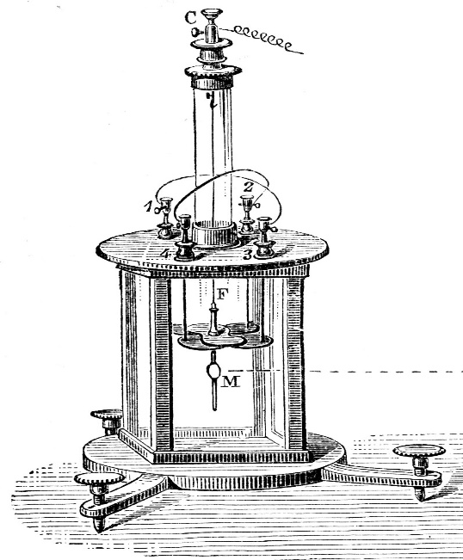

Figure 1 Electrometer (1924)

Experiments at that time were observed to be conducted on animals, such as muscle movements were observed when amputated limbs were given electrical impulses. These were the earliest stages of recording any kind of impulse. Figure 1 shows an electrometer used to record electrical impulses in the early 20th century.

However, with the passage of time science and technology has evolved and has led to great discoveries and innovation. Nowadays scientists and doctors use advanced machinery to help them achieve what the previous inventors only dreamed of doing.

In 1929 a German scientist first invented an EEG machine which could record electrical impulses. He observed that changing the condition of the body stimulated different voltages of current from the body. As many great scientist, he was ahead of his time and his work was not given credit for half a decade until his work was recognized. After the foundation, had been settled many scientists made different discoveries out of this was the discovery of finding tumour in the brain, by sticking numerous electrodes scientists could by that time discover anomalies in the brain.

## EEG Signals

Our brain contains huge number of individual cells called neurons.  Neurons communicate with each other through electrical pushes and pulls, and individual neuron push is too weak to be detected at a distance.  However, large number of thousands or millions of neurons with synchronized activities can be detected on various scalp locations and are called brain waves. They are measured in cycles per second, or Hertz.

 Scalp EEG activity shows oscillations at a variety of frequencies. Several of these oscillations have characteristic frequency ranges, spatial distributions and are associated with different states of brain functioning (e.g., waking and the various sleep stages). These oscillations represent synchronized activity over a network of neurons. The neuronal networks underlying some of these oscillations are understood (e.g., the thalamocortical resonance underlying sleep spindles), while many others are not (e.g., the system that generates the posterior basic rhythm). Research that measures both EEG and neuron spiking finds the relationship between the two is complex with the power of surface EEG in only two bands (γ and δ waves) relating to neuron spike activity

The various brain wave frequencies are studied extensively and generally correspond to different types of brain activities. Some of the frequencies are as follows:

* Beta (β) wave: from 12-40Hz with most energy between 20-30Hz, associated with attention and fast activities.  It is a broadband signal, caused by superposition of many randomly timed activities.  It is often used as simple indicator for Focus or Attention.
* Alpha (α) wave: generally, from 8-12Hz with significant variations, associated with relaxation and when eyes are closed. Certain fraction of the population has weak to undetectable alpha waves, and the Alpha wave centre frequency varies from person to person.  It is very narrowband signal, caused by synchronized activity of many neurons.
* Theta (θ) wave: generally, from 4-8Hz, associated with drowsiness.  It is a transitional wave, with few distinctive features.
* Delta (δ) wave: generally, from 0.5-4Hz, associated with deep sleep or deep relaxation. It is often in the form of strong pulse train with varying intervals, and thus often covers through δ, θ, α wave bands when it occurs.

Figure 2 Shows an EEG (electroencephalogram) chart of the brain waves of some common elements:

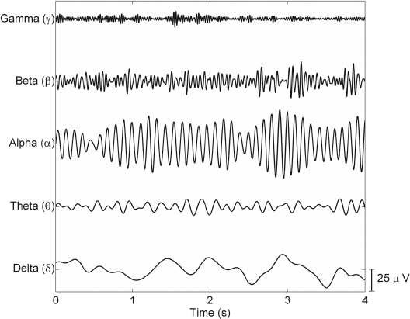

Figure 2 Different EEG signals

## Motivation

As Brain is the most complex part of the human body it is also very delicate. A small clot in the brain can cause permanent damage to the human body. Brain diseases are becoming common day by day. These brain diseases deteriorate the nerve cells which cannot be regenerated once they have died. This leads to diseases like Stroke, Alzheimer, Epilepsy and many more. The reason these diseases are dangerous is that they do not increase the mortality rate of the patients, all they do is make the patient bed ridden and make them unable to perform even the basic needs required to live independently.

A survey done in Pakistan recently found that over 20 million people were found with brain related problems and that is more than of heart and cancer patients combined. Reports and surveys done in Pakistan by different source say ‘around 3 million people suffer from epilepsy in Pakistan alone’. Brain disorders are an enormous burden for not only the patient but the society as well. Even if one elderly person is affected by it the whole family gets bound by the routine of the patient because he needs taking care of. Not to mention the financial crisis that one faces when dealing with the hospital and other fees. Figure 3 refers to the facts mentioned in this paragraph.

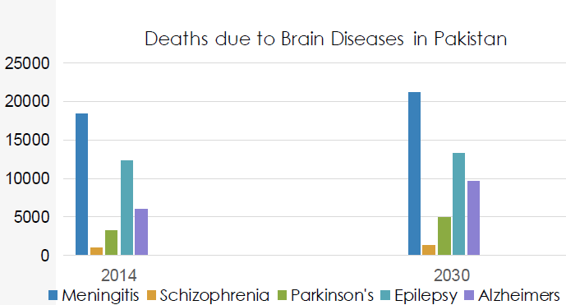

Figure 3 Comparison of Brain Related Diseases

The equipment needed to even set up a small brain related rehabilitation centre is very costly. It requires equipment to be imported from abroad and special licenses are involved in bringing the desired tools for the setup. For a country like Pakistan it is not feasible to setup rehabilitation centres with fairly new yet expensive equipment because the cost doesn’t give the profit to marginalize the procedure.

Another motivation factor is that we as human beings should be contributing something positive towards the world. All we have done is taken from the people around us now it is time to give something back. It is time to contribute to make this world a better place by helping the people who are in need of it. A lot of people suffer from brain diseases daily and in rural areas majority of the people are not able to afford the luxuries of the procedures which come with heavy bills for even a small check-up. We were motivated to build a cheap yet effective device to solve the problems which have been growing day by related to brain diseases and give a chance for the lower-class people who cannot afford the expensive treatments given by the imported machines which are only found in hospitals.

## Objectives

The objectives of the project are given as follows:

* To create an EEG machine that is able to facilitate in the rehabilitation of stroke patients.
* A device which is portable and easily manageable.
* A device which is cheap so it can be bought and used by the people who cannot afford expensive procedures
* Acquire and Detect the brain’s intention from MRCP and stimulate the patient accordingly

Figure 4 specifies the above-mentioned objectives.

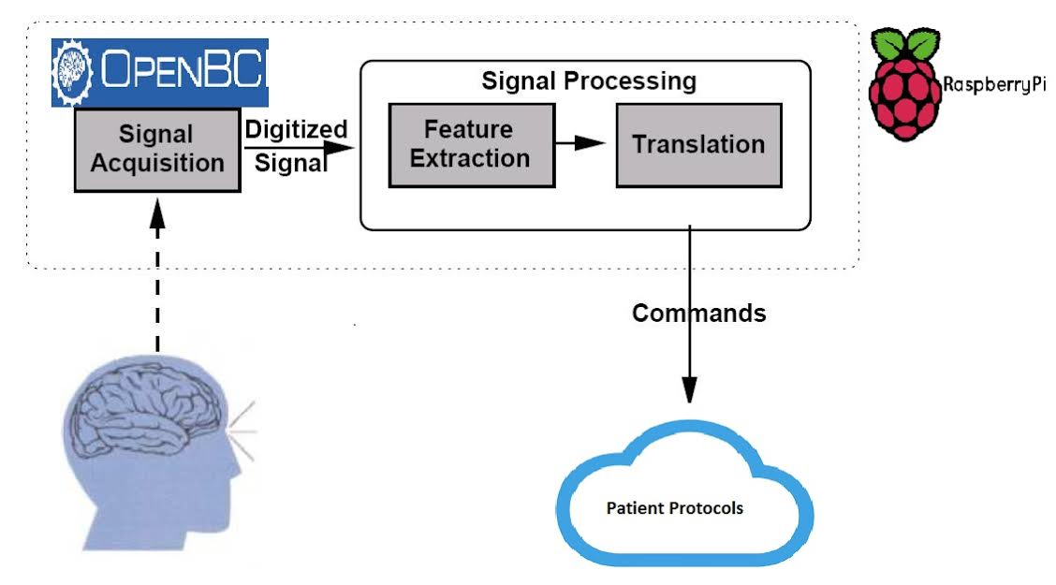

Figure 4 System Level Diagram

# Chapter 2: System Overview

## System Overview

This project involves acquiring brain signals from electrodes which are gold plated and are specially placed in distinct locations on the scalp to obtain the signals. With the help of a device known as Open Brain Computer Interface (BCI) the signals which were received as analogue are converted into digitally readable signals. The signals are transferred to Raspberry Pi where they are filtered and analysed upon.

## Tools:

The tools used are divided into two segments:

* Hardware tools
* Software tools

This project is on the basis of attaining signals which means that hardware and software tools are required to be in sync because it is impossible to attain the desired results without one another.

### Hardware Tools

#### OpenBCI

Open BCI is an open source platform created by Joel Murphy and Conor Russomano (as shown in figure 5). As the name suggests it is a gateway towards the signals of the brain. The device is an 8-channel 32-bit board which means that it can take readings from up to 8 different locations at a time. It also consists of an extension known as daisy which allows for the user to access 16 different locations of the brain at a time and it is known as Daisy.

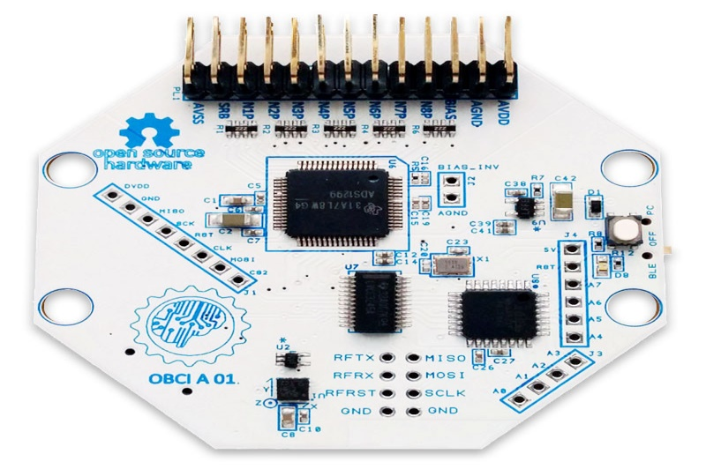

Figure 5 Open BCI

Specifications:

* Power with 3-6 volts battery
* ADS1299 Analogue front end
* LIS3DH 3 axis accelerometer
* RFduino BLE radio
* Micro SD card slot

Open BCI uses RFduino for its transfer of data wirelessly from the board to the connected device. It can connect to any device which supports Bluetooth Low Energy (BLE). While connected, it allows the general serial communication while supporting the Open BCI streaming data mode which allows for the data to be transferred smoothly.

#### Electrodes

These are used for acquiring the signals from the scalp. The electrodes are cast of pure silver with heavy gold plating at the disc. They are non-sterile and the wires are insulated by PVC to get the optimum result (refer to figure 6).

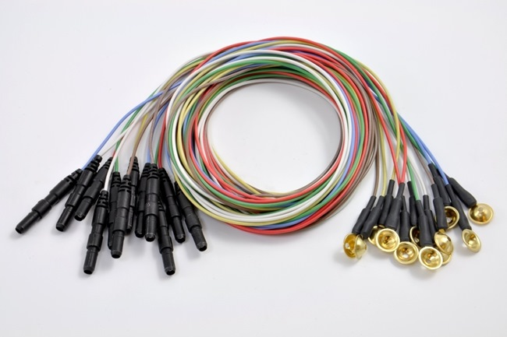

Figure 6 Gold Plated Electrodes

The reason we were getting accurate results was due to the fact of the accuracy of the plates. The gold-plated discs found at the end of the electrodes provide a perfect conductance platform which allows for us to observe with minimum external and internal noise.

#### Raspberry Pi

The Raspberry Pi is a complete computer adjusted in a single board which is of the size of a credit card. It was formed so people from all walks of life could have the opportunity to use a personal computer. The UK based foundation came up with the idea and people have been using it ever since. Although it may be small it can perform very complex operations with a particularly low cost. Figure 7 shows the diagram of Raspberry Pi.

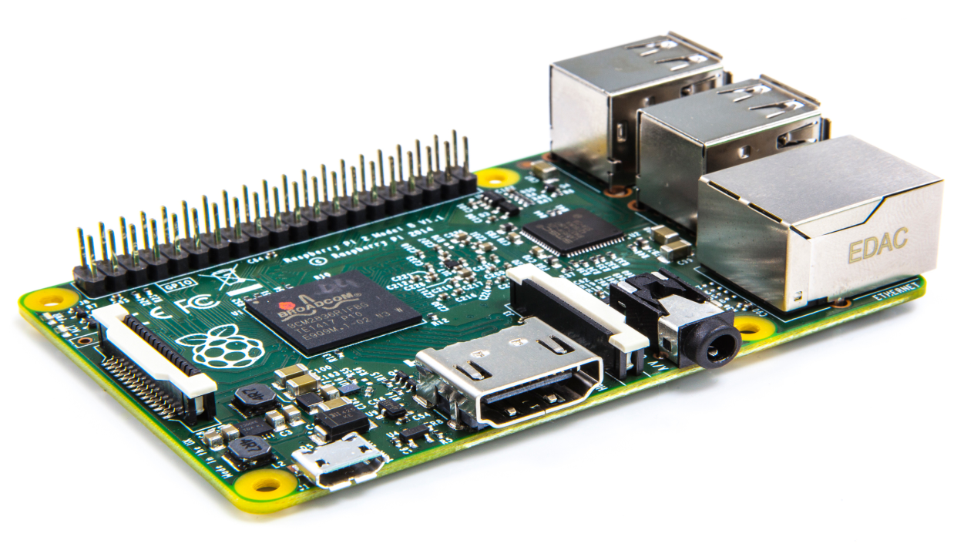

Figure 7 Raspberry Pi

**System Hardware and Interface:**

**Processor:**

Pi uses a processor which consists of a 700 MHz ARM processor which is somewhat based on the Broadcom2835. The new models have a 2gb ram with a video core GPU. The processor is placed directly under the ram chip to save space. This allows for the small computer to run smoothly without any lag or delay.

**RAM:**

In the older models, it started off with 128 mb of ram allocated to the pi and 128 given to GPU. This did not produce positive results as the speed was very slow. Later on, around 200mb was saved for the CPU which made for the 1080p video rendering or decoding possible. Later when technology improved the pi received an upgrade of 1gb ram. This was more than enough for the pi to be run smoothly because its performance was increased ten folds.

**Networking:**

An Ethernet port serves the purpose for providing an internet connection for the pi. Through this they can be connected to the internet. Another technology that has recently been made is Wi-Pi. It is a module which allows the pi to connect to the internet wirelessly to any open connection.

Installing a Raspberry Pi operating system image

The foremost thing is that an SD card with the image of the latest Raspbian operating system should be downloaded from their official website. Below are the steps involved to successfully install the OS:

* Insert the SD card to the SD card reader. See the drive that has been assigned to it. It will later be used.
* A disk imager utility is needed to mount the image that has been downloaded by the official website and convert it into a bootable device.
* Run Win32 Disk-Imager utility in the administrator mode
* Select the SD cards drive which we had previously seen and select it. Selecting the wrong drive will result in the whole image being formatted.
* Click write for the write operation to commence, exit the program and take the SD card out

### Software Tools

The below mentioned software tools have assisted us in achieving our desired results:

#### Raspbian

Raspbian is an operating system specially designed for Raspberry Pi. It is based on Linux but unlike Linux it has a completely working GUI once the system is booted. Raspbian has pre-compiled software’s which are free to use and packages are also pre-installed so that the user might not feel any difficulty.

Jessie (named after the toy story characters) is the latest OS that Raspbian has to offer. It is an easy to use GUI friendly OS which is being used by most people who are getting their first-time experience on Linux. Figure 8 is a logo of the operating system.



Figure 8 Raspbian Jessie Operating System

#### OpenBCI GUI

It is a default software tool for visualizing, recording and streaming data from the OpenBCI board. It can be launched as a standalone application or launched from a java based programming language. This GUI helps us to see the different actions visually. It is basically the connection between the brain and the board. We are able to detect the intentions as wave transforms.

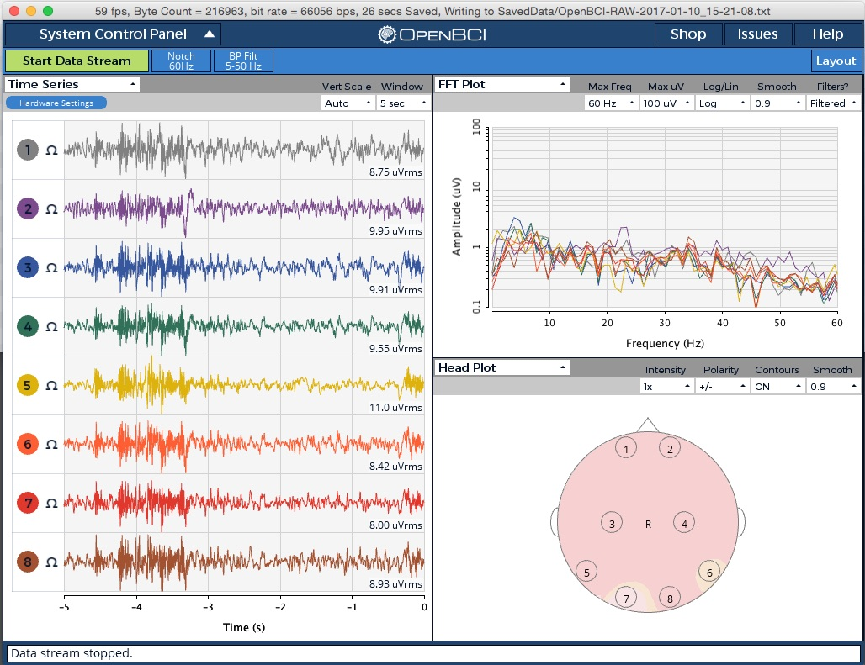

Figure 9 OpenBCI GUI

It has multiple features. From figure 9, we can see that it is showing the eight channels separately which are connected to the skull through electrodes.

It also shows the head plot which tells us that from which section of the head the alterations are coming from.

The Fourier transform plot shows us the frequency of the electrical impulses that is occurring in our brain.

All in all, the OpenBCI GUI helped us in creating a great understanding towards the basics of acquiring eeg signals.

#### Python

Python nowadays has become a commonly used high level programming language. It gives the user the ability to write very complex pieces of code to be expressed in small code, allowing producing a very readable code with very less extensive and complex coding. It also assists object oriented and functional programming.

Most operating systems do not require python to be installed as it comes pre-installed in the newer versions of most Linux based operating systems making it less hectic rather than installing the python interpreter.

Figure 9 is the logo of the Python language.



Figure 10 Python Language

#### OpenBCI Python

This is a specific library only designed to work with the OpenBCI hardware. It gives the user access to directly interface with the OpenBCI. With this library, the user can acquire data as well as write data. However, users should be familiar with the python language before accessing this library.

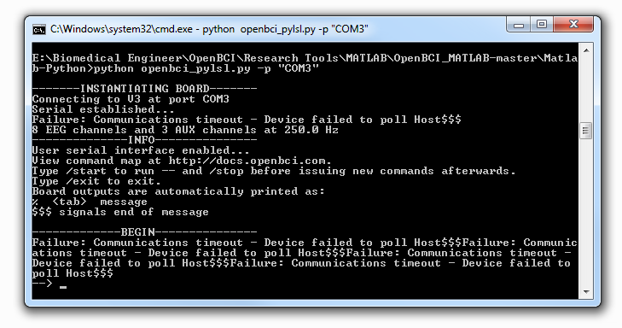

Figure 11 Python OpenBCI Interface

In figure 11, the OpenBCI is establishing a serial connection in the windows platform.

#### Pyserial

This library allows for the access of the serial ports. It provides back ends for python that is running on the windows. However, this is only available on Python 2.7 or higher versions.

#### Pylsl

The pylsl library deals with the streaming data and implements the lab streaming layer protocol that is implemented for data transfer and streaming between OpenBCI and the Raspberry Pi

#### Multiprocessing

Python multiprocessing is a very strong library that is used for parallel computation. As per the requirement of dedicated hardware, OpenBCI acquires and samples the data in time frames with a specific frequency. In order to keep that smooth and perform other calculations in parallel, like plotting, filtering and classifying the signals, multiprocessing is necessary.

#### Multithreading

To perform multiple tasks along with processes, multithreading is necessary e.g. to show different plots of EMG and EEG signals, in different windows, that are being updated regularly

#### Scipy

Scipy is responsible for all the DSP involved after acquiring the raw signals. It has built in low pass filters, high pass filters , band pass filters , band stop/notch filters . We can calculate the energies of signals and observe the frequency response of signals using FFT (fast fourier transform). Furthermore, the filters being applied can be selected to be IIR e.g. Butterworth filters with custom orders, or FIR (infinite impulse response, or the finite impulse response).

#### Matplotlib

It is an already built plotting library in python. It allows for the user to generate histograms, bar charts, scatter plots and many more types of graphs. The coding in plotting these graphs is not very complex as python allows for a relatively small code.

#### Tenser Flow

It is a software library which is open source library which allows numerical computation using data flow graphs. Which means it is available to everyone who wants to use it any way possible. It has a flexible architecture which allows which allows us to deploy computations to one or more systems if needed. It has changed the machine intelligence community as with its new technology researchers and engineers have been able to perform operations that were very difficult to achieve before.

# Chapter 3: Interfacing OpenBCI with MATLAB and Pi

## Interfacing Open BCI with MATLAB

Initially we aimed to use MATLAB for the processing of EEG signals and then analysing the results obtained. For this purpose, we firstly needed to interface the MATLAB software with the Open BCI that was used to acquire the EEG signals. We used the Lab Streaming Layer (**LSL**) tool for this purpose. Lab Streaming Layer (LSL) is an important networking tool used for synchronizing streaming data for the real-time streaming, recording and analysis of bio data. The *OpenBCI_matlab.py* program uses Python to establish an LSL stream that can be received using scripts in MATLAB. The real-time streaming of data using MATLAB requires certain steps to be performed.

### Open BCI LSL Setup:

Before following the setup instructions, we need to make sure that the following programs and files have already been downloaded on the computer:

* MATLAB
* Python (either version 2.7 or 3.5)
* Open BCI_MATLAB files from GitHub

1. **Downloading the Open BCI_MATLAB repository from Git Hub**

For downloading the Open BCI_MATLAB repository from Git Hub, either type: git clone [1] on the command line OR click the “Clone or Download” button on the right top corner of the page and click “Download Zip”. Unzip the file and save it to the directory of your own choice.

1. **Setting up of Python**

* **Install python and pip**

1. Download and then installing Python (version 2.7 or 3.5) on the computer.
2. Checking if pip is also installed

* On the command line, enter: pip list. If you see a list of modules on the screen as output that means pip is installed.
* **Install libraries**
  + - 1. If you have pip installed, navigate to the "Matlab-Python" directory on your terminal/command line and type: *pip install -r requirements.txt.*
      2. If you do not have pip installed, then you can manually install the two libraries: pyserial and pylsl.

1. **MATLAB Setup**

Now before performing the next few steps we will assume that a recent version of MATLAB is already being installed on your computer.

* Adding the “labstreaminglayer” directory to your MATLAB path. Following two methods can be applied to do this:

1. **Method One: ** On the Matlab command line, type the following:

`>> addpath(genpath('/path/OpenBCI_MATLAB/Matlab-Python/labstreaminglayer')) `

(Replace "path" with the path to where you downloaded this repository)

1. **Method Two: ** Go to **Environment** on your Toolstrip and click **Set Path**. Click **Add with Subfolders** and select the folder *labstreaminglayer* from the Github download.

Testing if LSL is correctly installed and set up in MATLAB, enter the following command on your MATLAB command line:

>> lsl_loadlib()

If you do not get any error message that means LSL is installed correctly.

**Usage:**

Now, for receiving the data streaming into MATLAB

1. Start the streaming with the OpenBCI_matlab.py program.
2. Receive the stream with an lsl script in MATLAB.

* **Starting a stream in python**

Once you have plugged in the dongle into the port and powered up the Open BCI board, you can freely navigate to the “Matlab-Python” directory on your command line and then enter: *python OpenBCI_matlab.py -p "PORT".*

**\*The PORT should be replaced with the serial port that your USB dongle in being plugged into.**

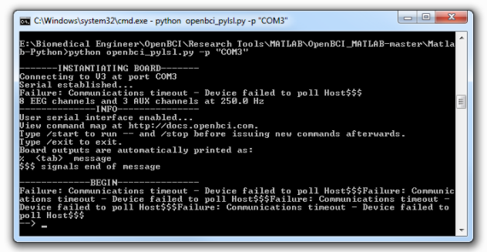

Figure 12 User Interface

Figure 12 is a description of command prompt used to run the library.

Some commands that can be useful in controlling the streaming of data as are follows:

1. To start the streaming type “/start”.
2. To stop the streaming type “/stop”.
3. To disconnect from the serial port type “/start”

Some parameters relating to the Open BCI board and serial port related information will appear on the command line. After the board initialization, you should see “BEGIN” and a new prompt on the command line. You are now ready to start the streaming.

* **Receiving the streaming data in MATLAB**

Following script shows the basic script that is used to receive the streamed data into chunks for a specific time interval and then displaying the results. The data can be saved in a vector and can directly work on the EEG signals in MATLAB using this script and also making the changes where required.

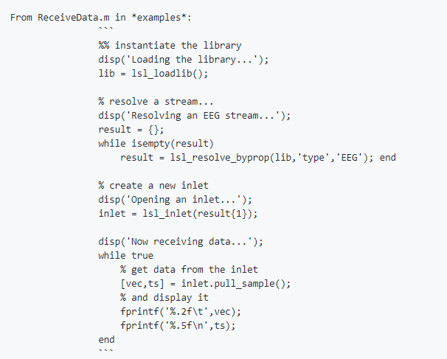

The data stream from the Open BCI board is now pushed into the lab streaming layer. The next step is to receive this data in MATLAB by running the above script.

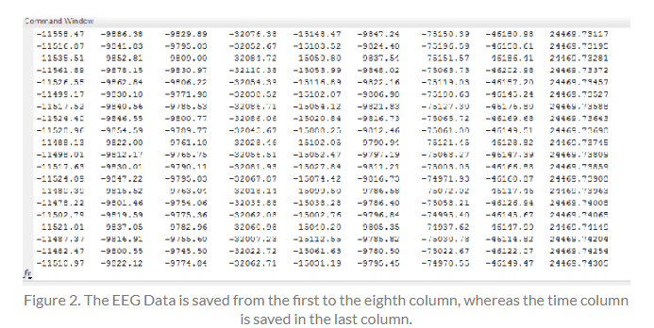

Figure 13 EEG Data

Figure 13 shows the successful streaming of data into MATLAB after completing the above required steps. The first eight channels are shown in the figure as the first eight columns that are the EEG data. While the last column shows the time in milliseconds.

**Monitoring in MATLAB:**

You may also want to monitor your streamed data in MATLAB before you can deploy any scripts in MATLAB to ensure that the bio data is correctly streaming in MATLAB. Using the “*vis_stream*” command in the MATLAB command window, you can not only set the parameters including the type and the frequency of the signals but also to visually obtain the data streamed through the eight channels in the form of waves showing the output at each channel. Figure 14 is an input vis_stream window.

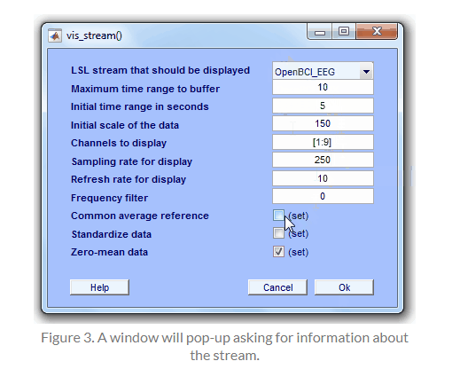

Figure 14 Vis_Stream Input Window

Figure 15 shows the output of the brain waves for the eight input channels. Now we can work on them. Besides we can change the scale with up and down arrows on the keyboard.

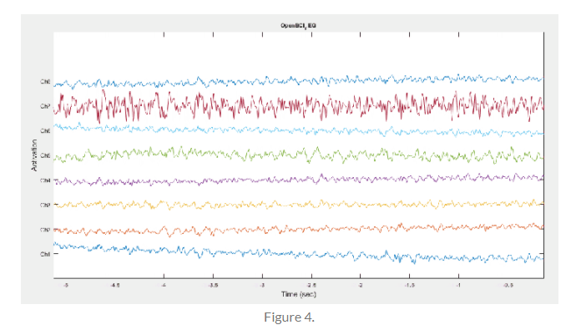

Figure 15 Output of EEG

If you want to stop the streaming or disconnect from the serial port, just come back to the command line and type “/stop” or “/exit” and the streaming will stop.

## Interfacing Open BCI with Raspberry Pi

Our actual goal was to acquire signals from a portable device so this requires successful interfacing of OpenBCI with an “embedded system”. As explained earlier, pi is a relatively cheaper and a very powerful device so it can perform the acquisition and seamless processing of the incoming signals. These are the necessary steps required to observe brain activity and data transfer between OpenBCI and Raspberry Pi B-II.

### OpenBCI Python

Start by downloading the python repository from Here [2]. Follow the initial steps from 3.1.1(2) for python and library installation. Once the repository is downloaded follow the given steps for installation: -

* Hit Alt + Ctrl + T, this will open up the Linux terminal.
* Then download all the necessary libraries given in 2.1.2 (Python) This can be done manually via python index webpages, or automatically using the pip guide for python.
* After the libraries are installed, navigate to the scripts folder in the downloaded repository using “cd” and “ls” commands.
* Read the “OpenBCIv3.py” library. This is the key file that has to be imported in order to communicate with the OpenBCI hardware.
* This callback function can be called with the “Startstreaming(callback_function)” function from the OpenBCIv3.py library.
* In this callback function, one can achieve data sample by sample and based upon sampling frequency checks (i.e. 256 normally and 128 with the daisy module), and implement the necessary functionality i.e. filtering the signals.
* Now going back to the terminal, we can run this script (EEG.py) using the command “sudo python EEG.py”.

# Chapter 4: OpenBCI SETUP

## Initial Setup

### What you need

After the interfacing of the Open BCI board with MATLAB is done, we’ll now look into how the electrodes are connected to the board and their connection with the head and body. For the physical connection of the electrodes with the body and recording the EEG signals through Open BCI, initially there are some necessary requirements to be made:

* Ten20 paste for electrode conduction (or any other conductive electrode gel).
* Cyton Board
* USB Dongle
* Battery Pack
* X4 AA Batteries
* X8 gold cup electrodes (from your Open BCI kit)

There may also be some optional material required:

* Paper towel for cleaning excess Ten20 paste from the body.
* Medical Tape for adding extra stability to the electrodes while they are being placed on the body.
* Ear swabs for cleaning paste from the electrodes once the acquisition of the signals is done.

### Connecting the electrodes to the Open BCI

We’ll now connect the eight electrodes that we are using with the Open BCI board.

1. Connect the white electrode to the SRB2 pin (the bottom SRB pin). This pin is used as the reference pin for all the Open BCI input channels.
2. Connect the black electrode to the bottom BIAS pin. This pin is similar to the ground pin of the common EEG systems, but it uses destructive interference waveform techniques to eliminate the “common mode noise” of all of the active channels.
3. The remaining 6 electrodes used will be connected to any of the remaining top (P input) pins or bottom (N input) pins from N1P to N8P.

## Placement of Electrodes

The placement of the gold-plated electrodes on the scalp as shown in figure 16 for the acquisition of the brain signals is made in accordance with the International 10 20 system. “10 20 system or “International 10 20 system” of electrodes placement is an internationally recognized system that is being commonly used to locate and apply the electrodes in context of the EEG signals related to an experiment or test. The name “10 20” describes that the distance between any two adjacent electrodes in either 10 % or 20 % of the total front-back or right-left distance of the skull.

Each lobe present on this system has an alphabet to identify the lobe and also has a number that shows the hemisphere location. The letters F, T, C, P and O stand for Frontal, Temporal, Central, Parietal and Occipital lobes respectively. The electrodes A1 and A2 are connected to the left and right earlobes and are used as the reference electrodes. All the even numbers (2, 4, 6, and 8) denote the right side of the brain or the right hemisphere while all the odd numbers (1, 3, 5, and 7) denote the left side of the brain or the left hemisphere. Letter “z” is used for the electrodes that are placed in the midline.

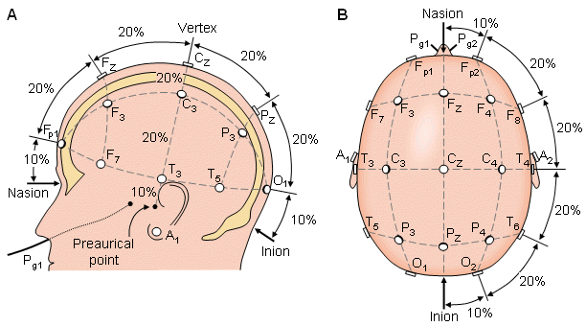

Figure 16 Position of different electrodes on the 10 20 system

The motor cortex is the region of the cerebral cortex that is responsible for the planning, control and execution of the voluntary movements. For differentiating between the neural activity for the classes of left hand movement and right hand movement using the EEG signals, the electrodes are localized on the motor cortex regions of the brain (around locations C3 and C4 for right and left hand movements respectively). The other 4 electrodes were also divided in a way that two electrodes each were placed close to the C3 and C4 channels so that relevant information spread over the regions close to these two positions may also be included in the analysis and will lead to improve performance. A total of two electrodes one on each earlobe will be placed from which one will be the reference electrode and the other will be placed to remove the noise from the surrounding. Finally, the remaining two electrodes are placed on the left and right palms for the recording of the EMG signals.

### Headset

One of the most important requirements for the acquisition of the EEG signals was the preparation of the Headset that would be applied on the subject so that the EEG signals could be acquired. For this purpose, we used a rubber cap that is normally used as a swimming cap. We placed 6 holes on the rubber cap and tried our best to locate the exact positions of the electrodes on the rubber cap including the C3 and C4 positions. Finally, before placing the electrodes on any position, firstly we filled the electrodes with the 10 20 paste to create conduction between Open BCI and the scalp and then placed the electrodes one by one of the relevant location on the cap.

## Acquisition and Processing of EEG signals

For the acquisition of EEG signals we firstly performed all the steps that were described in the previous section under Chapter 3. After the interfacing is complete, the headset is being placed on the subject’s head and all the electrodes are placed on their allocated positions. In this case a total of 6 electrodes are placed on the scalp, two are placed on the ear lobes and final two are placed on the palms to acquire the EMG signals. The next step after locating and placing all the electrodes on the subject is to place the USB dongle into the serial port and switching on the Open BCI board. A” /start” command on the command line starts the streaming of data through the Open BCI board.

### Protocol Definition

Now for differentiating the left and right hand movement through the EEG signals, it was important to set a defined protocol according to which it is decided before the acquisition of EEG signals that what would be the total length of the signal and during the signal, what would be the sequence and types of movements that will be performed by the subject and for how long? For this purpose, we recorded every EEG signal of 2 minutes (120 seconds) and we divided this time into three types of movements. First 10 seconds there was no movement, the next 10 seconds the subject moved his right fist or right hand and then the next 10 seconds the subject moved his left fist or left hand. The sequence of these actions was repeated until a signal of 2 minutes (120 seconds) was recorded.

### Implementation on Raspberry Pi

In the section 4.3.1, the R&D behind the band energies from MRCPs is used here. After successful interfacing of OpenBCI, as explained in chapter 3, we can now move on to the details involved in the theory and its implementation.

#### Filtering

Once the data has started getting received via serial port, it can be extracted from different channels. Each channel specifying the respective raw data, either EMG specifying arm contractions or EEG from C3 and C4 channels (in accordance with the 10-20 system) continuously being streamed via Bluetooth. Much information cannot be extracted from these raw signals, so they have to be filtered. There are two basic filters involved along with detrending.

##### **Signal Detrend**

In figure 17, we can see that each channel has a certain amount of DC offset, added by the vendor that has to be removed in order to process the data from these signals

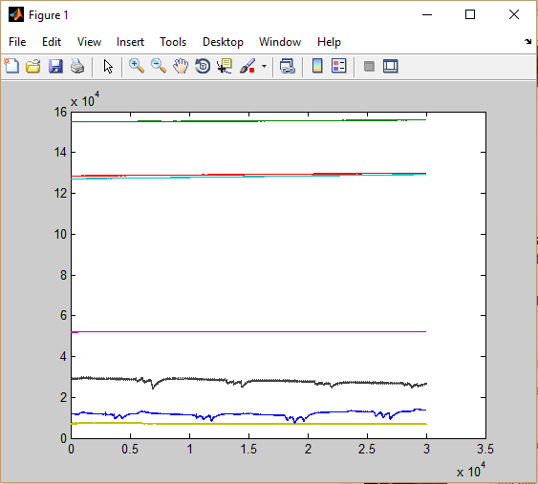

Figure 17 Signal Detrend

##### **Spatial Filtering**

Spatial filtering is used to increase the SNR before applying the DSP filters. The EEG activity in channels C3 and C4 is recorded by the interference of neighbouring channels, that leads to better energy calculations. A small Laplacian can help improve SNR of C3 & C4 channels.



As we can see that the overall weight of a Laplacian filter is equal to zero and the initial weight remains. Figure 18 shows the Laplacian filter applied on the scalp.

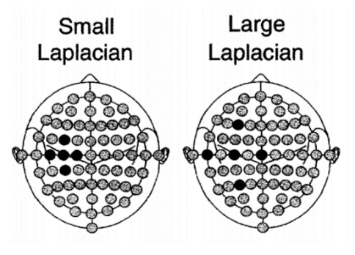

Figure 18 Laplacian Filter

##### **Digital Filters**

After dealing with the DC offset and the Laplacian we are now ready to apply DSP filters to raw signal. We apply these two filters

* 60 Hz Notch filter is there to remove the generic room interference and wire movement as shown in figure 20.
* Since we are observing the Beta rebounds of EEG signals, a bandpass filter from 8-30 Hz has to be applied.
* We can see the difference between a raw EMG signal (figure 19) and a filtered EMG signal(figure 21 & 22) where spikes show arm muscle contraction.

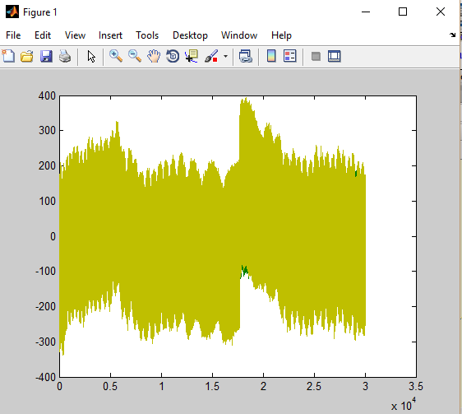

Figure 19 Raw EMG Signal (unfiltered signal)

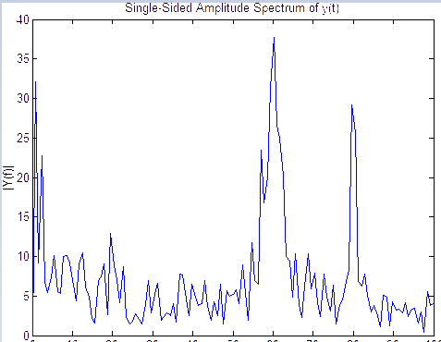

Figure 20 Frequency response for noise cancellation (notch filter)

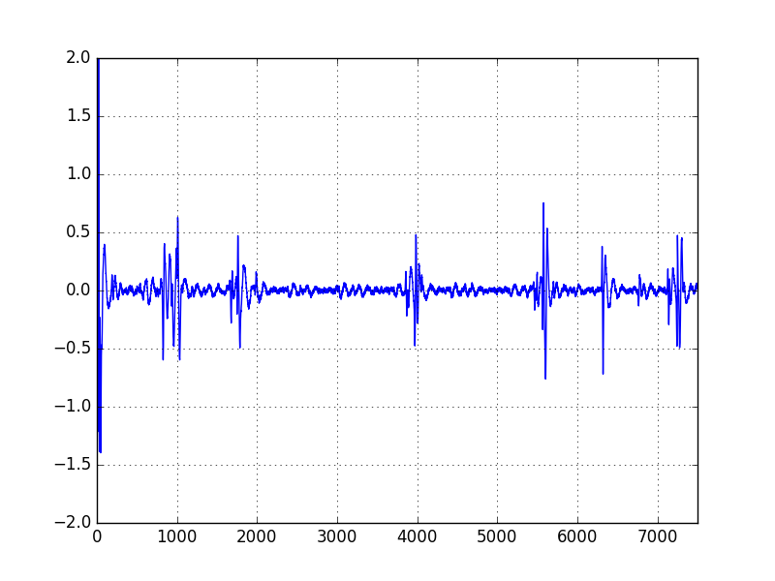

Figure 21 EMG for 6 contractions

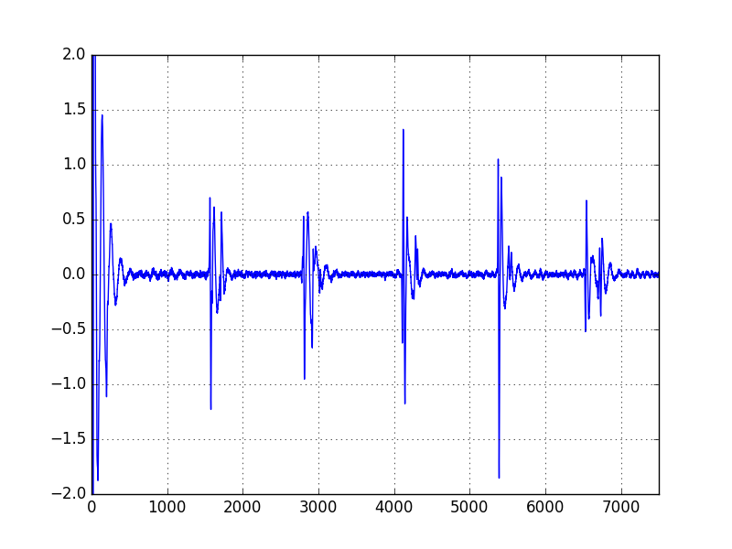

Figure 22 EMG for 6 contractions

#### Motor Imagery

When no sensory inputs or motor outputs are being processed, the mu (8–12 Hz) and beta (13–30 Hz) rhythms are said to be synchronized [3, 4]. These rhythms are electrophysiological features that are associated with the brain’s normal motor output channels [3, 4]. While preparing for a movement or executing a movement, a desynchronization of the mu and beta rhythms occurs which is referred to as ERD and it can be extracted 1-2 seconds before onset of movement (as depicted in Fig. 4). Later, these rhythms synchronize again within 1-2 seconds after movement, and this is referred to as ERS. On the other hand, delta rhythms can be extracted from the motor cortex, within the pre-movement stage, and this is referred to MRCP. The (less than 3 Hz) MRCP is associated with an event-related negativity that occurs 1-2 seconds before the onset of movement [5, 6]. Now the intention can be identified using the band energies of the beta rebounds i.e. desynchronization

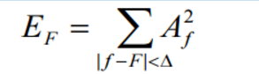

And this is implemented in python using the squared magnitude of “Fast fourier transform” of the required frequency and based on this, here is a frequency response (refer to figure 23) of acquired EEGs of right and left (B).

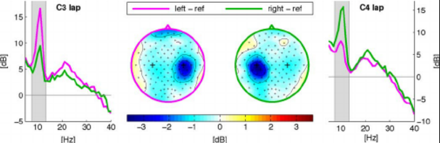

Figure 23 ERD in right and left hand of patient (B rebound)

#### Python 2.7

There are two separate files for the demonstration of EEG and EMG acquisition. The main part in the python code is the multiprocessing that is dealing with the acquisition, plotting and output generation in different processes. These processes interact with one another using the queues avoiding GIL (global interpreter lock). As explained in Ch 2 (python), the functionality of each library, i.e. scipy deals with the signal processing, OpenBCI_v3 deals with the board connections and GPIO deals with the output display. Please go through the code comments for further clarification of python implementation.

### Implementation on MATLAB

We acquired the signal for a total of 8 channels that included 6 channels of EEG signals and remaining two of EMG signals for showing the left and right hand movement. Initially we acquired the EEG and EMG signals and imported them in MATLAB. As EEG signals are known to be noisy and non-stationary, filtering the signals is an important step to get rid of unnecessary information from the raw signals. So, we firstly applied the band pass filter to the signals of frequency 8 to 30 Hz to extract the useful information from the raw signals and then further applying a 50 Hz band stop filter to remove the noise.

After filtering the signals we divided the data of each channel into 12 epochs because we had a signal of total length 120 seconds and we dedicated 10 seconds epoch to every type of movement (no movement (stop), right-hand movement (push) or left-hand movement (pull)), so in total we had 12 epochs for each of the 8 channels. We acquired the signals in a way as to differentiate between the numbers of movements of similar type within an epoch by changing the number of movements within an epoch. So firstly we acquired the signal with each epoch of 10 seconds and the sequence of movements followed was “stop”, “one time right-hand movement (push)”, “one time left-hand movement (pull)”. This sequence was repeated after every 30 seconds until we acquired the signal for 2minutes or 120 seconds. We also acquired the signals following the same sequence of movements as above but changing the number of movements in each epoch. After making the epochs for every channel we separated the stop, push and pull epochs from every channel and took their mean to obtain a stop, push and pull band each for the left and right side of the brain. Now to differentiate between the movements from either side of the brain, we calculated the band power of each type of epoch for both sides of the brain and this way we differentiated by evaluating the values and well as the plots for the three types of movements on both sides of the brain. The values of the band powers clearly showed the different of power between the left and right hand movement. But the difference can change depending upon the strength of the left or the right hand of the subject whose brain signals have been acquired.

Following plots (figure 24,25,26,27,28,29,30,31,32) show the difference between the amplitudes for the stop bands where there was no movement detected from the subject and the left or right hand where the amplitude of the signals increased due to movement from either hand. Also the band energies are shown that also indicates the difference of band power calculated for each band on either side of the brain.

**Epochs of Left and Right side of brain for one movement**

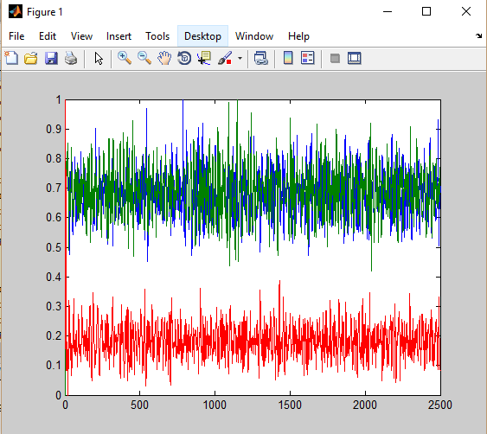

Figure 24 Plot shows the amplitudes of signals for the left, right and stop movements for the left side (right hand) of the brain. It is clearly visible that stop band (red) has low amplitude compared to push (right hand) and pull (left hand) bands.

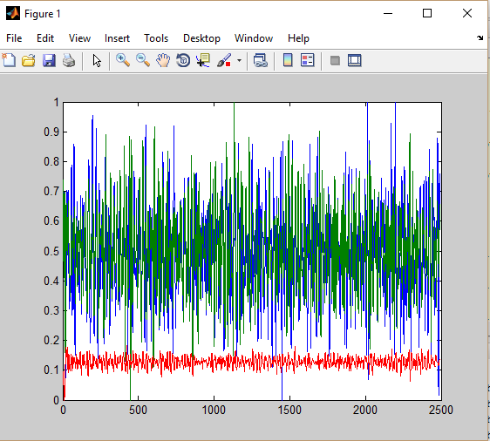

Figure 25 Plot shows the amplitudes of signals for the left, right and stop movements for the right side (left hand) of the brain. It is clearly visible that stop band (red) has low amplitude compared to push (right hand) and pull (left hand) bands.

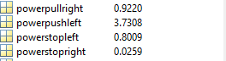

Figure 26 The power of the movements show the “powerpushleft” is greater than “powerpullright” as the subject has the right hand being the stronger one. The stop bands where there was no movement show power close to zero.

**Epochs of Left and Right side of brain for two movements**

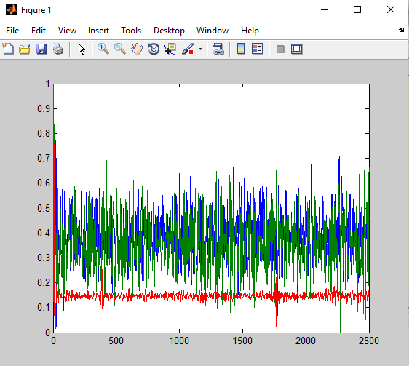

Figure 27 Plot shows the amplitudes of signals for the left, right and stop movements for the left side (right hand) of the brain. It is clearly visible that stop band (red) has low amplitude compared to push (right hand) and pull (left hand) bands

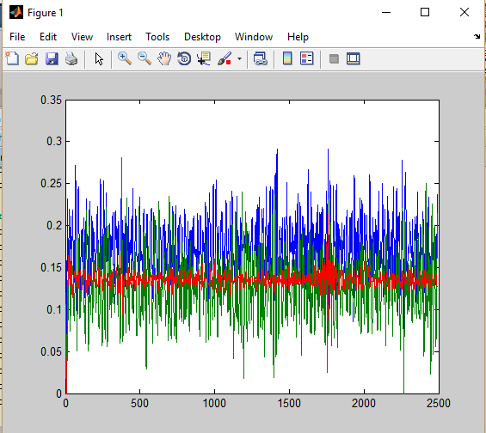

Figure 28 Plot shows the amplitudes of signals for the left, right and stop movements for the right side (left hand) of the brain. It is clearly visible that stop band (red) has low amplitude compared to push (right hand) and pull (left hand) bands.

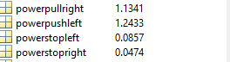

Figure 29 The power of the movements show the “powerpushleft” is greater than “powerpullright” as the subject has the right hand being the stronger one. The stop bands where there was no movement show power almost zero.

**Epochs of Left and Right side of brain for three movements**

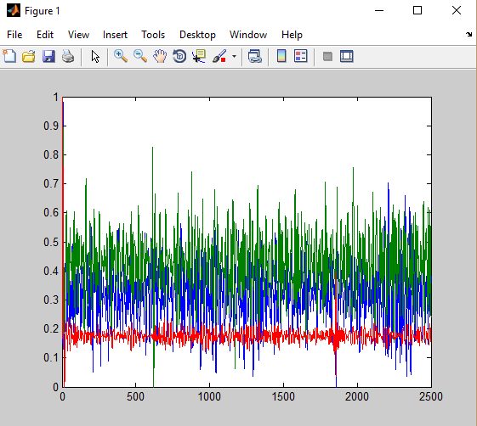

Figure 30 Plot shows the amplitudes of signals for the left, right and stop movements for the left side (right hand) of the brain. It is clearly visible that stop band (red) has low amplitude compared to push (right hand) and pull (left hand) bands.

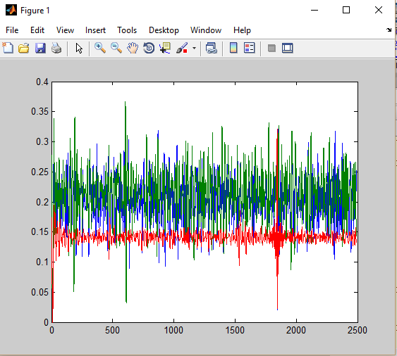

Figure 31 Plot shows the amplitudes of signals for the left, right and stop movements for the right side (left hand) of the brain. It is clearly visible that stop band (red) has low amplitude compared to push (right hand) and pull (left hand) bands

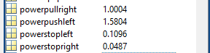

Figure 32 The power of the movements show the “powerpushleft” is greater than “powerpullright” as the subject has the right hand being the stronger one. The stop bands where there was no movement show power almost zero.

# CONCLUSION

The analysis of brain activity is a complex and meticulous task. It requires identification of exact cortical potentials and extract necessary functionality from it. We achieved the milestones of successful interfacing with MATLAB and also embedded system (Raspberry pi). Now our device is ready to acquire and process EEG signals that can identify brain’s intention for the movement of right and left hand. Based on this identification, we are currently stimulating through the GPIO pins of the raspberry pi but it can be moulded into a practical FES (Functional Electrical Stimulus) for the rehab of stroke patients.

# FUTURE WORK

The above stated work is expected to further aid the research regarding Motor Imagery and the classification of muscle movement intention from MRCPs. In the long run our work is expected to contribute in the following way: --

* Aid in the rehab of stroke patients by the development of cheap and portable devices based upon the strategies followed here.
* Classification of Signals for the detection of brain related diseases.
* Mobile application aiding the patients and physician for constant and remote monitoring
* Cloud storage of patient records (signals)

# REFERENCES

[1] <https://github.com/gabrielibagon/OpenBCI_MATLAB.git>

[2] <https://github.com/OpenBCI/OpenBCI_Python/tree/master/scripts>

[3] J. Wolpaw, N. Birbaumer, D. McFarland, G. Pfurtscheller, and T. Vaughan, "Brain-computer interfaces for communication and control," Clinical Neurophysiology, vol. 113, pp. 767-791, 2002.

[4] A. Bashashati, M. Fatourechi, R. Ward, and G. Birch, "A survey of signal processing algorithms in brain-computer interfaces based on electrical brain signals," Journal of Neural Engineering, vol. 4, pp. R32- 57, 2007.

[5] A. Vuckovic and F. Sepulveda, "Delta band contribution in cue based single trial classification of real and imaginary wrist movement," Medical and Biological Engineering and Computing, vol. 46, pp. 529 – 539, 2008.

[6] Y. Gu, K. Dremstrup, and D. Farina, "Single-trial discrimination of type and speed of wrist movements from EEG r

[7] Mohammad H. Alomari, Aya Samaha, and Khaled AlKamha Applied Science University Amman, Jordan ,Automated Classification of L/R Hand Movement EEG Signals using Advanced Feature Extraction and Machine Learning.